**Initial Imports:**

import numpy as np

import matplotlib.pyplot as plt

import pandas as pd

import seaborn as sns

%matplotlib inline

**Reading dataset:**

data = pd.read_csv("filename.csv")

1. # Preview the first 5 lines of the loaded data
2. data.head()

**Creating a data frame:**

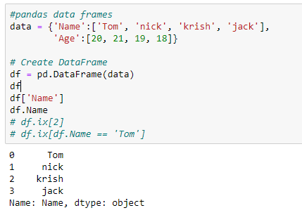

[**https://www.kaggle.com/kanncaa1/logistic-regression-implementation**](https://www.kaggle.com/kanncaa1/logistic-regression-implementation)

**Confusion matrix and train test splits and sensitivity,specificity,roc,auc:-**

**After** getting our entire dataset

<https://www.ritchieng.com/machine-learning-evaluate-classification-model/> ---> for logistic regression

Type1 → FP

Type2 → FN

**Kaggle - Breast Cancer Dataset:**

**All classification models**

[**https://towardsdatascience.com/building-a-simple-machine-learning-model-on-breast-cancer-data-eca4b3b99fa3**](https://towardsdatascience.com/building-a-simple-machine-learning-model-on-breast-cancer-data-eca4b3b99fa3)

**Linear Regression : R squared, RMSE**

[**https://towardsdatascience.com/a-beginners-guide-to-linear-regression-in-python-with-scikit-learn-83a8f7ae2b4f**](https://towardsdatascience.com/a-beginners-guide-to-linear-regression-in-python-with-scikit-learn-83a8f7ae2b4f)